**Compliance and Regulatory Analytics - Manufacturing Sector**

GOKULNATH K & E24755

**Overview**

Compliance and Regulatory Analytics in the manufacturing sector involves ensuring operations meet legal and industry standards by tracking and analyzing data on health, safety, quality, and environmental factors. Data analysts play a critical role in monitoring compliance metrics, identifying potential regulatory risks, and optimizing processes to maintain standards. They support audits by preparing accurate reports and documentation that demonstrate adherence to regulations. This work not only minimizes risk and penalties but also enhances overall operational efficiency and product quality.

**Objective**

1. **Monitor Regulatory Compliance**: Ensure all processes meet industry and legal standards.
2. **Identify and Mitigate Risks**: Spot potential compliance risks and implement data-driven safeguards.
3. **Support Safety and Environmental Standards**: Track safety, health, and environmental data for compliance.
4. **Provide Audit-Ready Documentation**: Prepare accurate reports for audits.
5. **Optimize Processes for Compliance**: Improve processes to meet standards efficiently.
6. **Predict Compliance Issues**: Use analytics to forecast and prevent non-compliance.
7. **Foster Continuous Improvement**: Enhance compliance practices through ongoing analysis.
8. **Collaborate with Key Departments**: Work with teams to ensure unified compliance efforts.

**Assigned Task(s)**

* Compliance and Regulatory Analytics - Manufacturing Sector.
* **Status:** Completed.
* **Details:**

1. Visualized total violations by compliance type to identify high-risk areas.
2. Created a bar plot displaying average inspection scores for each plant.
3. Developed a stacked bar plot to show violation severity levels by compliance type.
4. Illustrated the distribution of Environmental Index scores across different plants.
5. Analyzed the trend of compliance violations to assess changes over time.
6. Visualized Environmental Index scores by plant and compliance type to evaluate performance.

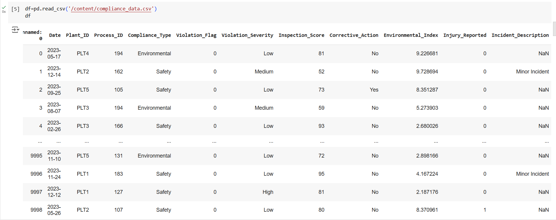

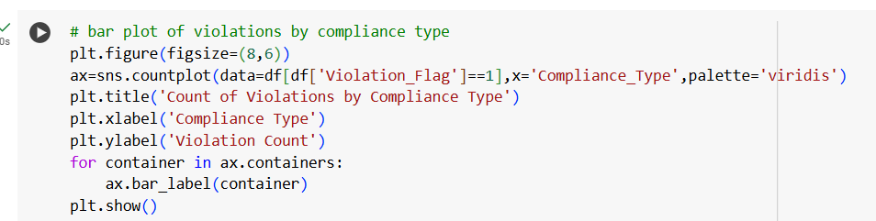

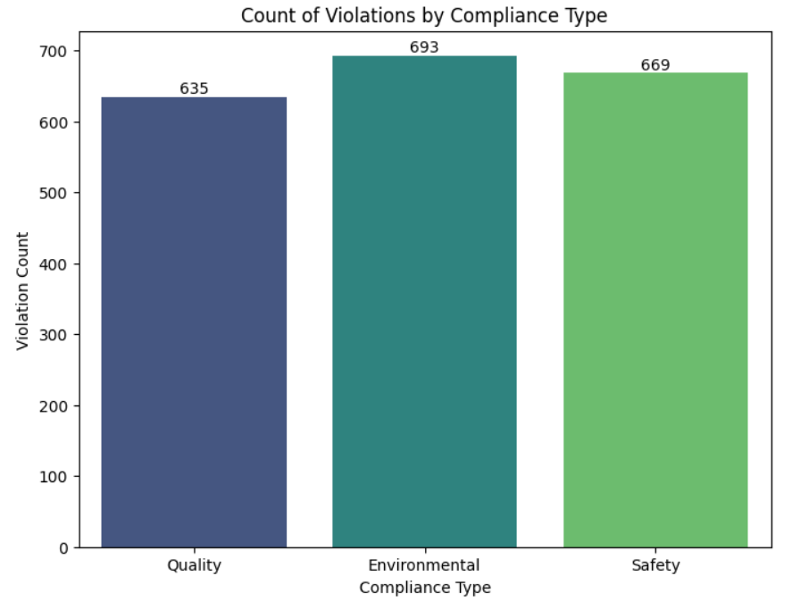

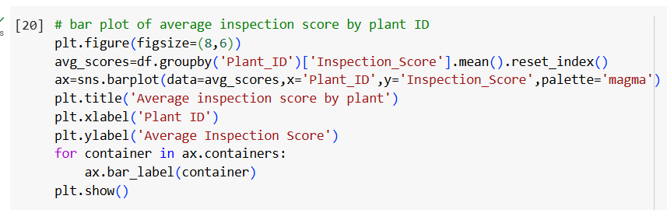

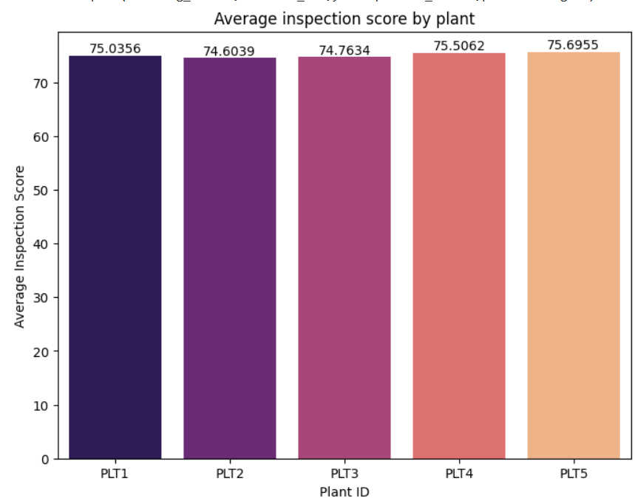

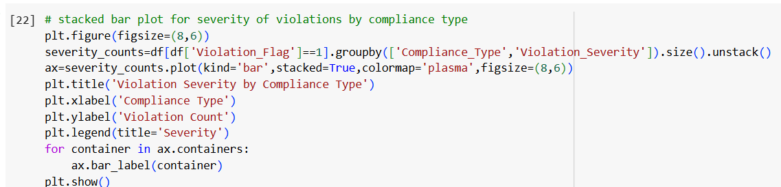

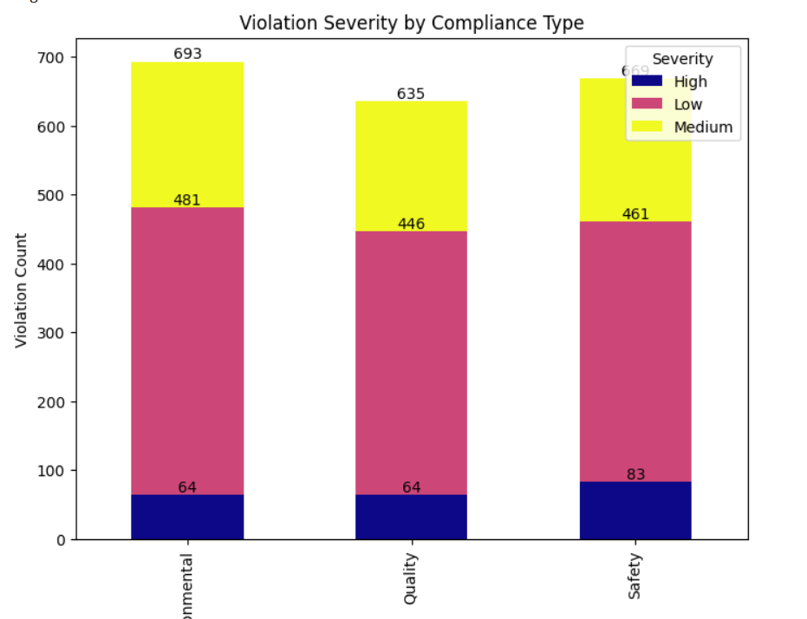

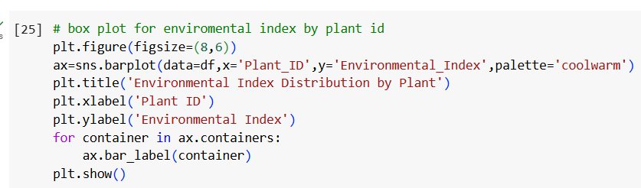

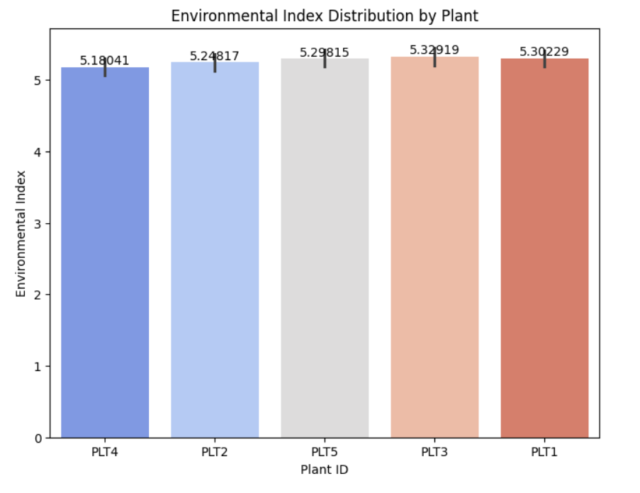

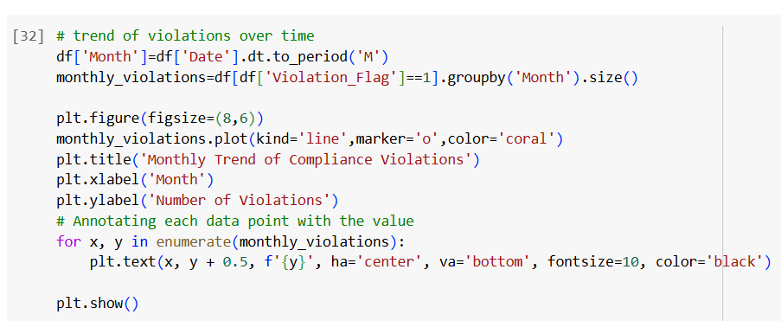

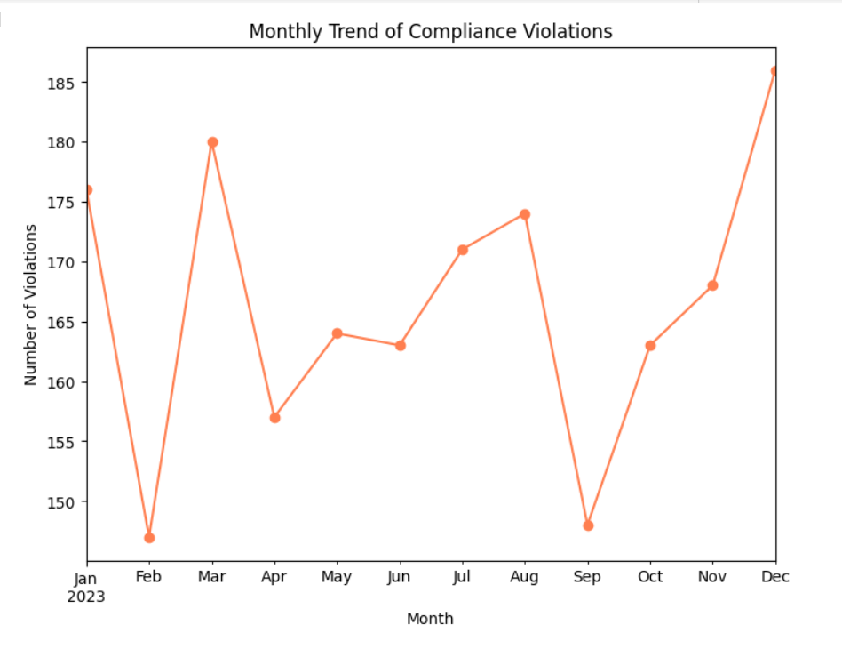

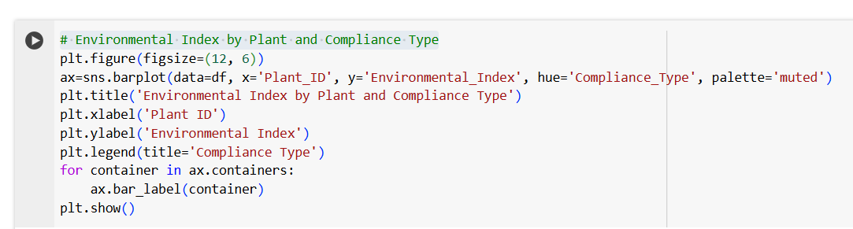

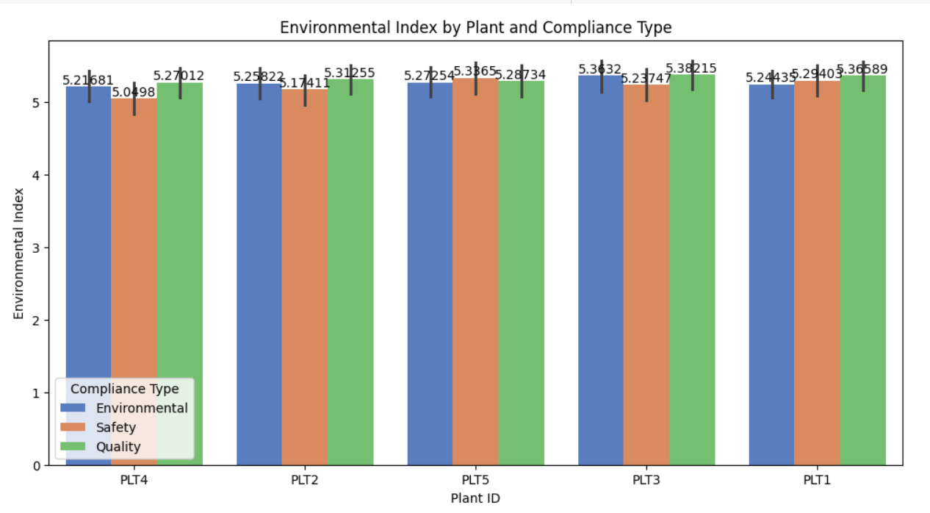

**Progress**

* **Accomplishments:**

1. Visualized total violations by compliance type to target improvement areas.
2. Analyzed average inspection scores by Plant ID for performance insights.
3. Illustrated violation severity levels by compliance type to communicate risks effectively.
4. Compared Environmental Index scores across plants using box plots.
5. Analyzed violation trends to assess compliance initiatives' effectiveness.
6. Visualized Environmental Index by plant and compliance type for better understanding.

* **Metrics:**

1. Measures the total number of compliance violations per type, indicating areas with higher risks.
2. Reflects the average compliance inspection scores across different plants, helping assess overall performance.
3. Quantifies the number of violations categorized as Low, Medium, or High severity, providing insights into the seriousness of compliance issues.
4. Represents the distribution of environmental performance scores across plants, highlighting those needing attention.
5. Analyzes the number of violations over time to identify patterns or improvements in compliance behavior.
6. Assesses environmental performance related to specific compliance types, aiding in targeted improvement efforts.

**Challenges and Solutions**

* **Challenges Faced:**

1. Inconsistent or incomplete data can lead to inaccurate analysis.
2. Insufficient resources (staff, budget, technology) to conduct thorough analyses.

* **Solutions Implemented:**

1. Implement data validation processes and regular audits to ensure data accuracy and completeness.
2. Prioritize analytics initiatives based on impact and feasibility, and seek external partnerships for expertise.

**Next Steps**

* **Upcoming Tasks:** To effectively tackle upcoming tasks in the manufacturing sector, prioritize clear objectives, leverage data-driven insights, and foster collaboration across teams.
* **Goals:** Regularly review key performance indicators (KPIs) and adjust strategies as necessary to stay on track toward achieving goals.

**Conclusion**

* **Summary:** In the manufacturing sector, Compliance and Regulatory Analytics plays a crucial role in ensuring adherence to regulations and improving operational efficiency. By leveraging data analytics, organizations can identify high-risk areas, monitor compliance trends, and enhance environmental performance. Implementing effective visualizations and metrics fosters informed decision-making and drives continuous improvement. Ultimately, these efforts lead to better compliance outcomes, reduced risks, and sustainable manufacturing practices.
* **Acknowledgements:** Thank you all for your attention and engagement, I appreciate your interest in the Compliance and Regulatory Analytics - Manufacturing Sector.